**MCS 4663: Operating Systems PA01 Abdullah S. Alajaj**

**C++ Code:**

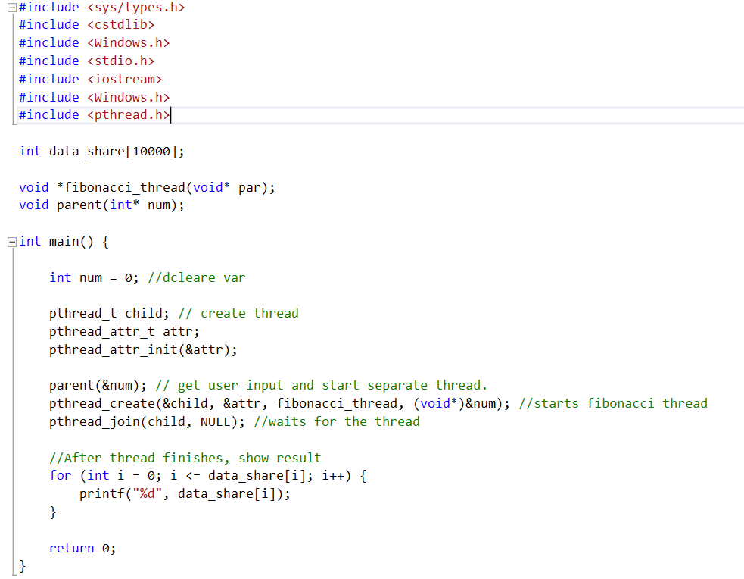

*(continued on next page)*

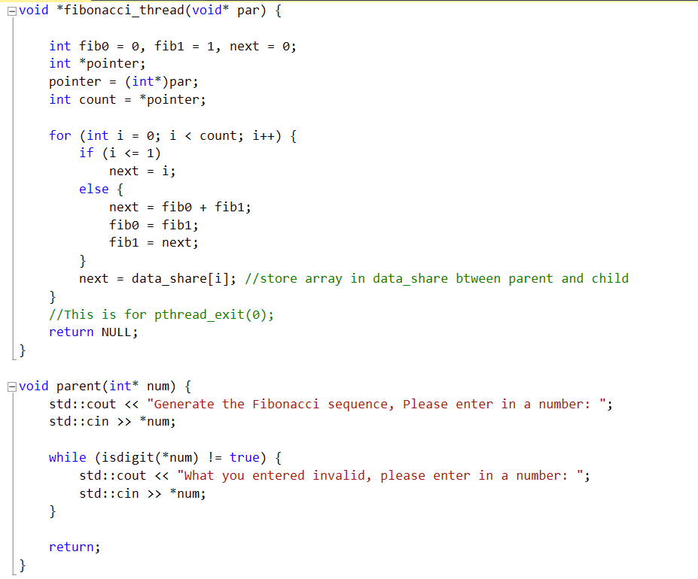

**JAVA code:**

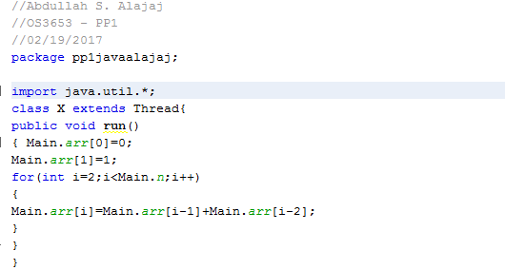

*(continued on next page)*

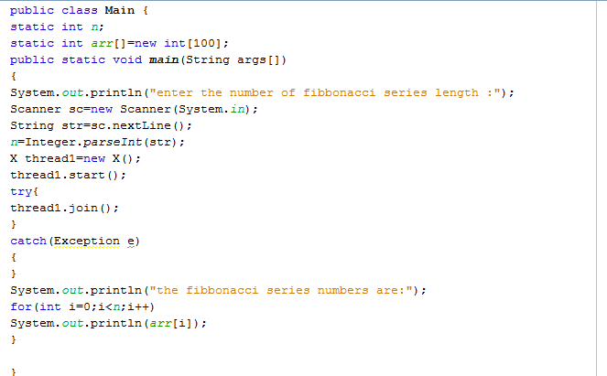

**Logical Flow Structure:**



The above image is the program’s logical flow structure, which physically shows the processes the program takes and the relationship between the Parent and Child.

**Program Executed:**

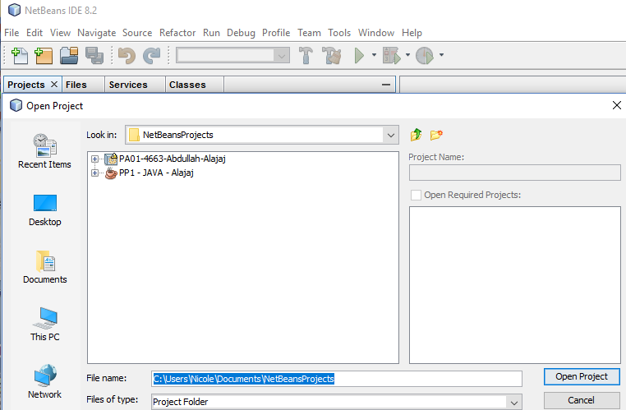

Click ‘File’ on the top menu bar of the NewBeans IDE program. Select ‘Open Project’ and find the project file within designated folder. Then click on the ‘Open Project’ button in the bottom right corner of the pop-up menu. See image above. ‘Program Executed’ section is continued on next page.

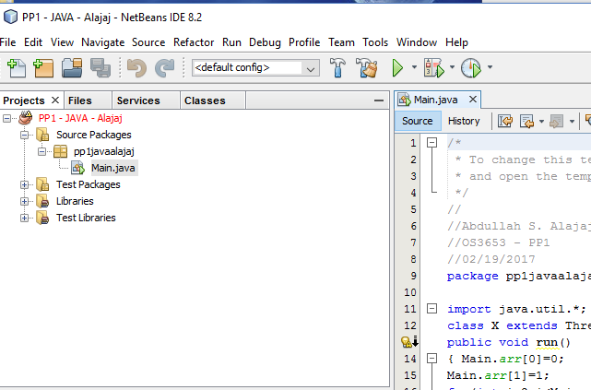

Expand the project folder by clicking on the ‘+’ sign next to the project name, and then expand the ‘Source Packages’ folder. Next, open the code folder and double-click on the ‘Main.java’ code.

Once the code is open in the right-hand select of the program, click on the ‘Run’ button in the top menu bar and select ‘Run Project’. The program will start to run. See image above.

**Show Results:**

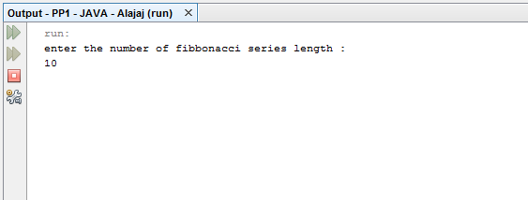

The program will ask the user to ‘enter the number of fibbonacci series length’. Once the length is entered, the user will have to click on the ‘enter’ button on the keyboard for the program to continue. See image above. ‘Show Results’ section is continued on next page.

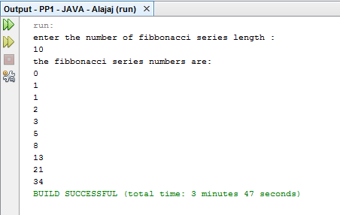

After the user clicks ‘enter’, the program will process and display the Fibbonacci series numbers into an array. Then the program is complete. See image above.